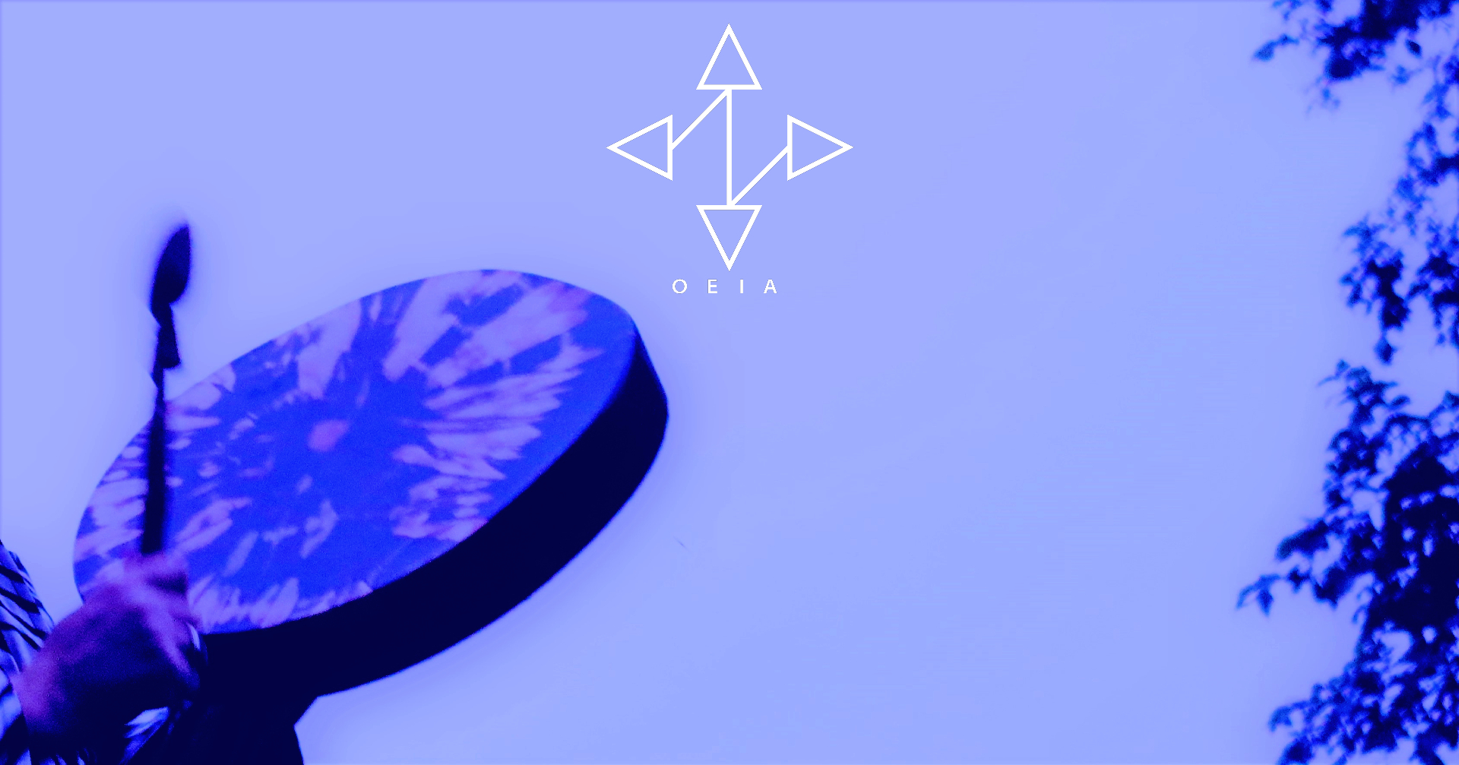 |  |  | Heather Clear Wind’s Offerings
Indigenous Nature Meditation (45 minutes to 1 hour)
Heather will guide us in a nature meditation to help raise awareness to the amazing connections we all have to the elements and to nature, and what a great support this can be. She’ll help you to experience nature and the elements in ways you may not have considered before. She shares Indigenous teachings about her beautiful intimacy with the elements and nature which are her wahkohtowin ᐊᐧᐦᑯᐦᑐᐃᐧᐣ (community) and are what helped her survive through the negative impacts of colonization, when humans failed her growing up.

Indigenous Nature Meditation Creation (1.5 hours)
This is the same offering as the above but with the second half being with time for people to create being held in ceremonial space and by being inspired by nature and the elements as the foundation for their creations.

Indigenous Drum Journeying (1 to 1.5 hours)
This ceremony is for your spirit to journey to the drumbeats of the drum. It can provide transformative healing, clearing and it can ground you. It can be a journey to get information, to answer a question, to connect with your power animal, your ancestors, to gain support in spirit from myriad nature, to help you release what no longer serves you, to help strengthen and raise your awareness to your connection to spirit, to Creator and to all of life. It can be to help you connect to your inner child and / or parts of yourself you may not be aware of, and to your authentic self. Each person's journey is unique. ❤ You can set an intention at the start for whatever you’re seeking. Some refer to this as shamanic journeying – I do not, as I am not a shaman but experiences are of a similar nature.

Compassionate Inquiry (1.5 hours)

Compassionate Inquiry is an effective tool at helping you to get in touch with your authentic self and with your feelings (physical and / or emotional).
Compassionate Inquiry was taught to me by world-renowned trauma and addictions expert, Dr. Gabor Maté.
It really aligned with my intuitive spiritual counselling work so I integrated the two and I indigenized it with ceremony.
I introduced a nature meditation that helps you to connect with nature and the elements, and sharing some Indigenous teachings so that you can connect to nature and the elements in ways you may not have considered before, and as a support prior to going into experiencing your feelings.
I also provide an alternative mindfulness approach to acknowledging and honouring the feelings by being present with them, without necessarily going into them directly, which is also effective and can be helpful because avoidance, suppression and denial of feelings can cause needless suffering.
Compassionate Inquiry can help you to release whatever you are feeling (physically and / or emotionally), carrying and / or holding. It is said that all pain arises from a disconnection from the true self. Compassionate Inquiry can be a way back home to your authentic self, as well as a way to connect with your inner child / inner children.
In the simplest terms, all you need do in order to experience Compassionate Inquiry, is to become more present and mindful. Surrendering your logical mind and allowing yourself to become more aware of what you're feeling (emotionally / physically), and trust and allow yourself to be guided in our group.
This isn’t like other groups as the work is done internally so your information remains private as I guide the group in a general way and however I am guided by spirit. Please bring a journal as you may want to take notes.
 | Toronto
 | http://soulpurposehealing.weebly.com/

